

PROJECT TITLE

A CAPSTONE PROJECT REPORT

AI-Based Intelligent Maze Navigation and Optimal Path Planning System
CSA 1717-Artificial Intelligence
to the award of the degree of
BACHELOR OF TECHNOLOGY
IN
ARTIFICIAL INTELLIGENCE AND DATA SCIENCE

Submitted by
(192524237)ATHIN SIVA.S
GUIDED BY
Dr. M.Anoop

SIMATS ENGINEERING
Saveetha Institute of Medical and Technical Sciences
Chennai-602105

SEPTEMBER 2026

SIMATS ENGINEERING

Saveetha Institute of Medical and Technical Sciences

Chennai-602105

BONAFIDE CERTIFICATE

This is to certify that the Capstone Project entitled “AI-Based Intelligent Maze Navigation and Optimal Path Planning System” has been carried out by ATHIN SIVA.S under the supervision of Dr. M.Anoop. The work is submitted in partial fulfilment of the requirements of Artificial Intelligence and Data Science Engineering, Saveetha Institute of Medical and Technical Sciences, Chennai.

COURSE COORDINATOR COURSE FACULTY
Title / Name, Dr.M.Anoop
Designation Associate Professor
Branch / Department Name Computational Datascience
SIMATS Engineering, SIMATS Engineering,
SIMATS, Chennai – 602105 SIMATS, Chennai – 602105

SIMATS ENGINEERING

Saveetha Institute of Medical and Technical Sciences

Chennai-602105

CERTIFICATE FROM THE SUPERVISOR

COURSE COORDINATOR | SUPERVISOR
Dr. Krishna Kumar Kathiresan | Dr. M. Anoop
Professor | Associate Professor
Department of Generative AI | Department of Computational Data Science
Saveetha School of Engineering | Saveetha School of Engineering
SIMATS | SIMATS
This is to certify that the project entitled AI-Based Intelligent Maze Navigation and Optimal Path Planning System” submitted by ATHIN SIVA.S student of Artificial Intelligence And Data Science at Saveetha Institute of Medical and Technical Sciences, Saveetha University, Chennai has been carried out under my supervision. The project has been submitted as per the requirements in the current semester of B. Tech ARTIFICIAL INTELLIGENCE AND DATA SCIENCE

INTERNAL EXAMINER EXTERNAL EXAMINER

SIMATS ENGINEERING

Saveetha Institute of Medical and Technical Sciences

Chennai-602105

DECLARATION

I am ATHIN SIVA.S of the Artificial Intelligence and Data Science Engineering, SIMATS Engineering, Saveetha Institute of Medical and Technical Sciences, Chennai, hereby declare that the Capstone Project Work entitled “AI-Based Intelligent Maze Navigation and Optimal Path Planning System” is the result of my own bonafide efforts. To the best of our knowledge, the work presented herein is original, accurate, and has been carried out in accordance with the principles of engineering ethics and academic integrity. All sources, references, data, and other materials used in the project have been appropriately acknowledged. We further declare that the data, results, analysis, and findings presented in this report have not been fabricated, falsified, or manipulated. Any external tools, software, datasets, computational resources, or AI-assisted tools used during the project have been appropriately disclosed. We confirm that all applicable ethical, academic, institutional, and professional requirements have been duly followed throughout the planning, execution, analysis, and documentation of the project.

Place: Chennai

Date:5/09/2026

Signature of the Students with Names

ATHIN SIVA.S(192524237)

INDIVIDUAL CONTRIBUTION STATEMENT
The overall project was completed as a three-member team. The following allocation identifies the module responsibilities.
Student | Specific Responsibilities | Design & Development | Testing & Analysis | Report Contribution | Approx. Contribution
ATHIN SIVA S  (192524237) | Maze Generation & Environment Mapping | Maze creation and grid representation | Maze validation and grid testing | Module 1 report | 33.3%
M. VIDYADHAR  (192511467) | AI Pathfinding | A* search and path optimization | A* testing and comparison | Module 2 report | 33.3%
KUSHAL KUMAR  (192524068) | Visualization & Performance Analysis | Path visualization and metrics | Result analysis and A* vs BFS comparison | Module 3 report | 33.3%

ABSTRACT

The Maze Generation and Environment Mapping Module forms the initial computational layer of the proposed AI-Based Intelligent Maze Navigation and Optimal Path Planning System. The module accepts maze size and navigation settings, creates or loads a maze, validates the environment, and represents the maze as a searchable two-dimensional grid. Static obstacles such as walls are encoded as blocked cells, while traversable locations are represented as free cells. Start and goal positions are also defined so that the subsequent A* pathfinding engine can operate on a well-formed environment.
The module is important because the quality of path planning depends on the correctness of the environment representation. After generation, the maze is checked for valid dimensions, usable start and goal positions, and consistent obstacle representation. The resulting grid is passed to the AI Pathfinding Engine, which uses A* search to determine an optimal route. The module therefore provides a clear interface between user input, maze construction and intelligent path planning.
The implementation is designed in Python and supports visualization of the generated maze. The project presentation identifies Python, NumPy, Matplotlib and Pygame as the principal technologies. The module is applicable to autonomous robots, warehouse automation, self-driving vehicles, drone navigation, search and rescue and other navigation-oriented applications.
Keywords: Maze Generation, Environment Mapping, Static Obstacles, 2D Grid, A* Pathfinding, Optimal Path Planning.

TABLE OF CONTENTS
Sl. No. | Title | Page
1 | CHAPTER 1: INTRODUCTION AND ENGINEERING PROBLEM | 10–11
2 | CHAPTER 2: LITERATURE REVIEW AND EXISTING SOLUTIONS | 12–13
3 | CHAPTER 3: ENGINEERING DESIGN, TRADE-OFFS, SUSTAINABILITY, ETHICS, SAFETY, RISK & SECURITY | 14–17
4 | CHAPTER 4: IMPLEMENTATION, TESTING & RESULTS, PROJECT MANAGEMENT | 18–20
5 | CHAPTER 5: CONCLUSION, FUTURE WORK & INDIVIDUAL REFLECTION | 21
6 | REFERENCES | 22
7 | APPENDICES | 23

LIST OF FIGURES
Figure No. | Figure Name | Page
Figure 3.1 | Module 1 – Maze Generation and Environment Mapping Architecture | 15
Figure 3.2 | Module 1 – Maze Generation Flowchart | 16
Figure 4.1 | Sample Generated Maze with Static Obstacles | 19

LIST OF TABLES
Table No. | Table Name
Table 1.1 | Maze representation categories — 11 — 11
Table 3.1 | Stakeholder requirements for Module 1 — 14 — 14
Table 3.2 | Functional and non-functional requirements — 14 — 14
Table 3.3 | Module 1 design specifications — 14 — 14
Table 3.4 | Maze generation trade-off analysis — 16 — 16
Table 3.5 | Sustainability, ethics, safety and security considerations — 16 — 17
Table 3.6 | Module 1 risk register — 19 — 17
Table 4.1 | Hardware and software resources — 20 — 18
Table 4.2 | Module 1 test plan — 20 — 19
Table 4.3 | Functional test results — 19
Table 4.4 | Objective achievement — 20

LIST OF ABBREVIATIONS / SYMBOLS
Abbreviation / Symbol | Description
AI | Artificial Intelligence
A* | A-Star Search Algorithm
BFS | Breadth First Search
2D | Two-Dimensional
S | Start node
G | Goal node
g(n) | Cost from start to current node
h(n) | Estimated cost from current node to goal
f(n) | Total evaluation cost: g(n) + h(n)

CHAPTER 1

INTRODUCTION AND ENGINEERING PROBLEM

1.1 Background
Maze navigation is a core problem studied in Artificial Intelligence because it provides a clear environment in which an intelligent agent must make sequential decisions. In the proposed project, navigation is represented as a grid in which some cells are traversable and some cells are occupied by static obstacles. The first engineering task is therefore to construct an accurate representation of the environment before the pathfinding algorithm is applied.
The project presentation defines a sequential architecture consisting of User Input, Maze Generation, Environment Mapping, AI Pathfinding Engine, Obstacle Detection, Optimal Path Planning, Visualization and Performance Analysis. The Maze Generation module creates or loads the maze, while Environment Mapping converts it into a searchable grid. This report focuses on these first two responsibilities and their interface with the later A* stage.

1.2 Need for Module 1
- Provide a valid maze environment for the pathfinding engine.
- Convert the visual maze into a machine-readable two-dimensional grid.
- Represent static walls consistently as blocked cells.
- Provide valid start and goal positions.
- Prevent invalid maze input from reaching the A* pathfinding stage.
- Create repeatable environments for algorithm testing.

1.3 Problem Statement
Design and implement a maze input, generation and environment-mapping module capable of creating or loading a valid maze, representing static obstacles in a searchable grid, defining start and goal positions, and supplying a consistent environment to the AI Pathfinding Engine.

1.4 Aim
To develop a reliable maze-generation and environment-representation layer that converts user-defined maze information into a structured 2D grid suitable for optimal path planning using the A* algorithm.

1.5 Objectives
- Generate maze environments programmatically or load an existing maze.
- Represent the maze using a two-dimensional grid.
- Identify and encode static obstacles and free cells.
- Select and validate start and goal positions.
- Provide a clean input interface for A* pathfinding.
- Support visualization and repeatable testing.

1.6 Scope
The scope covers maze input, maze creation/loading, grid representation, static obstacle encoding and validation of the environment. It does not implement the A* search itself, which is assigned to the AI Pathfinding module. It also does not include moving or dynamic obstacles in the implemented system. Visualization and performance analysis are handled by the later module.

1.7 Maze Representation Categories
Cell Type | Representation | Meaning
Free cell | 0 | Traversable location
Static obstacle | 1 | Blocked wall/obstacle
Start | S | Initial agent position
Goal | G | Destination position

1.8 Assumptions and Boundary Conditions
- Maze dimensions are within the supported input range.
- Start and goal are inside the maze boundaries.
- Start and goal are not placed on static obstacle cells.
- The maze uses a discrete grid representation.
- The project uses static obstacles only.

CHAPTER 2

LITERATURE REVIEW AND EXISTING SOLUTIONS

2.1 Review Method
The review is organized around constructing a maze environment, representing that environment as a grid, and supplying it to a search algorithm. The project references include literature on A* pathfinding, neural A* search, autonomous path planning, improved A* approaches and comparative studies of DFS, BFS and A*.

2.2 Grid-Based Maze Representation
Grid-based representations are widely used for discrete navigation problems because they provide a direct mapping between locations and computational states. Each cell can be treated as a node, while valid movements between adjacent cells form the edges used by a search algorithm. For the present project, a simple representation is sufficient for static obstacles.

2.3 Maze Generation Approaches
Maze environments may be manually designed, randomly generated or loaded from predefined layouts. Manual layouts provide repeatability but limited variety. Random generation provides multiple test cases but must be validated. Loading predefined mazes is useful when comparing algorithms on identical inputs. The proposed module can support creation or loading while keeping the internal grid representation consistent.

2.4 Relationship to A* Pathfinding
The Maze Generation module does not decide the route. Its role is to supply a correct environment to the A* engine. A* then evaluates nodes using f(n)=g(n)+h(n). This separation allows the same maze to be used for different algorithms such as A* and BFS during performance comparison. For a grid with uniform movement cost, A* gives an optimal path when an admissible heuristic is used.

2.5 Comparative Analysis
Approach | Advantages | Limitations | Relevance
Manual maze | Simple and repeatable | Limited variety | Useful for demonstration
Random maze | Many test environments | Requires validation | Suitable for testing
Predefined maze | Identical inputs for comparison | Less flexible | Useful for A* vs BFS
Proposed grid module | Common representation for search | Depends on valid input | Selected approach

2.6 Engineering Gap
The key engineering requirement is the transition from a maze designed for human viewing to a machine-readable search environment. Without consistent cell encoding, obstacle identification and start/goal validation, the pathfinding stage cannot reliably operate.

2.7 Proposed Contribution
The module contributes a structured and reusable environment layer. It separates maze creation from pathfinding, allowing the A* engine to focus on route selection while the maze module manages grid construction, static obstacle representation and input validation.

CHAPTER 3

ENGINEERING DESIGN & TRADE-OFFS, SUSTAINABILITY, ETHICS, SAFETY, RISK & SECURITY

3.1 Stakeholder Requirements
Stakeholder | Requirement
Student/User | Enter maze size and define start/goal positions.
Project evaluator | Observe a practical AI maze-navigation environment.
Developer/Tester | Generate repeatable maze inputs for testing.
Pathfinding module | Receive a valid 2D grid with correctly marked obstacles.
Result analyst | Use consistent mazes for performance comparison.

3.2 Functional & Non-Functional Requirements
Type | Requirement | Verification Target
Functional | Create/load maze | Valid grid generated or loaded
Functional | Represent obstacles | Blocked cells correctly encoded
Functional | Set start/goal | Both positions valid and unblocked
Functional | Validate maze | Invalid input rejected
Functional | Provide search grid | Grid supplied to pathfinding
Non-functional | Repeatability | Same input can be recreated
Non-functional | Usability | Inputs and outputs understandable
Non-functional | Maintainability | Generation and pathfinding modular

3.3 Design Specifications
Parameter | Target / Requirement | Priority
Programming language | Python | High
Grid | 2D matrix | High
Obstacle model | Static blocked cells | High
Start/Goal | Valid grid coordinates | High
Visualization support | Maze and path display | Medium
Pathfinding interface | Grid passed to A* | High

3.4 Maze Generation & Environment Mapping Architecture
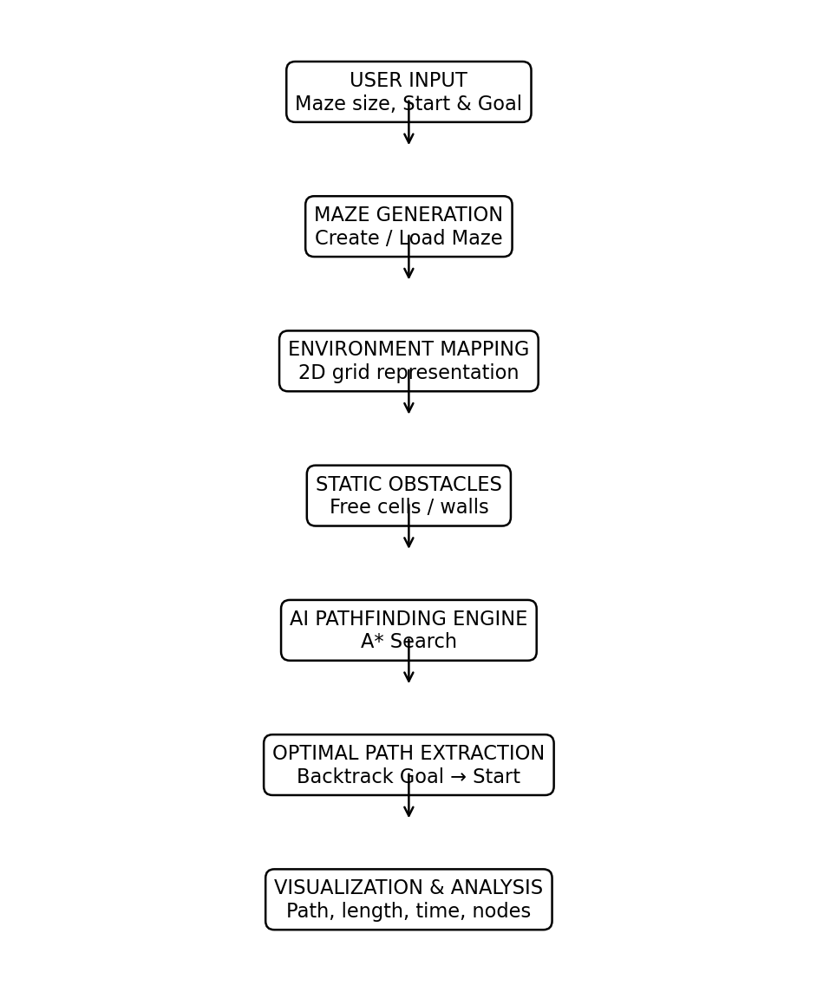
Figure 3.1 Module 1 – Maze Generation and Environment Mapping Architecture
The architecture shows how user input is transformed into a valid searchable environment. Static obstacles are represented before the environment is passed to the A* pathfinding stage.

3.5 Maze Generation Flow
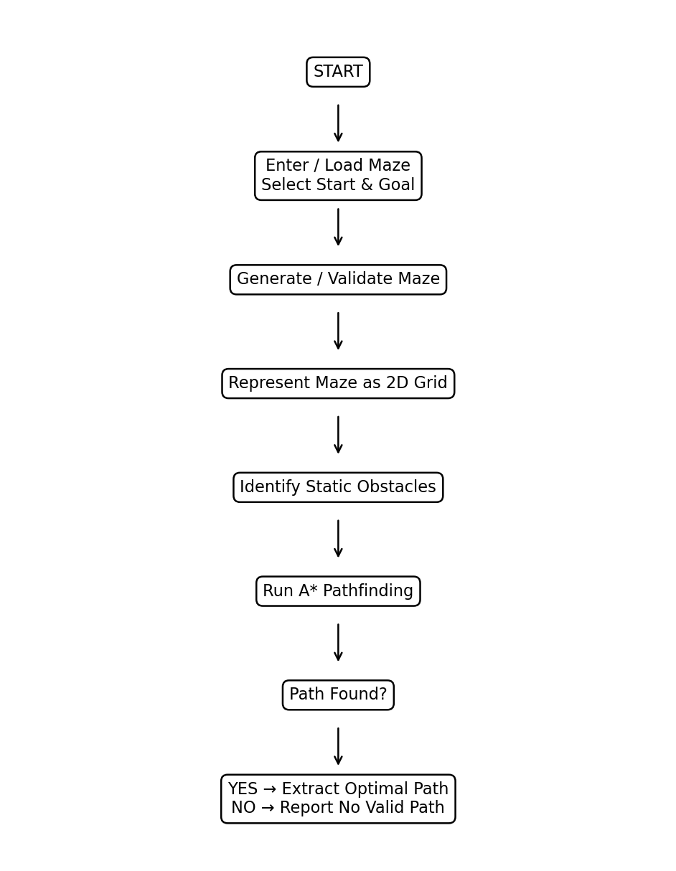
Figure 3.2 Module 1 – Maze Generation and Environment Mapping Flowchart
The flow begins with input and maze creation. The environment is mapped to a 2D grid, static obstacles are identified and the validated grid is supplied to A*. A valid path is later extracted if one exists.

3.6 Design Trade-Off Analysis
Design Decision | Alternative | Benefit | Limitation | Final Decision
Maze input | Manual only | Easy control | Limited variety | Generate / Load
Grid encoding | Complex object model | More detail | More complexity | Simple grid
Obstacle model | Dynamic obstacle model | Changing environments | Outside current scope | Static obstacles
Maze source | Random only | Many cases | May need validation | Validated generation/loading

3.7 Detailed Module Design
Component | Function | Output
User Input | Accept maze size/settings and S/G | Validated input
Maze Generator | Create or load maze | Maze layout
Grid Mapper | Convert layout into cells | 2D grid
Obstacle Handler | Mark static walls | Blocked cells
Validator | Check dimensions and S/G | Valid environment
Interface | Send environment to A* | Search-ready grid

3.8 Sustainability, Ethics, Safety & Security
Domain | Consideration | Engineering Impact
Sustainability | Uses common computing resources | Low-cost reusable prototype
Ethics | Do not claim unsupported performance | Evidence-based results
Safety | Incorrect representation can produce invalid navigation | Validate boundaries and obstacles
Security | Input/code files can be altered | Controlled inputs and versioning

3.9 Risk Register
Risk | Likelihood | Severity | Mitigation | Residual Risk
Invalid maze dimensions | Medium | Medium | Validate input | Low
Start/goal on obstacle | Medium | High | Reject invalid positions | Low
Unsolvable maze | Medium | Medium | Validate connectivity | Low–Medium
Incorrect obstacle encoding | Medium | High | Test representative grids | Low–Medium
Inconsistent test maze | Low | Medium | Save/reuse test cases | Low

3.10 Interface with Other Modules
Module 1 supplies the search-ready maze environment to the AI Pathfinding Engine. The interface preserves grid dimensions, obstacle locations, start position and goal position. The A* module then performs route selection without needing to know how the maze was created.

CHAPTER 4

IMPLEMENTATION, TESTING & RESULTS, PROJECT MANAGEMENT

4.1 Development Approach & Resources
The module was developed as the first computational layer of the complete maze-navigation system. The development sequence begins with input handling, followed by maze creation/loading, grid mapping, obstacle representation and validation. The resulting environment is then passed to the A* module.
Resource | Purpose
Python | Core implementation
NumPy | Grid/matrix operations
Matplotlib | Maze and result visualization
Pygame | Interactive visualization support
Laptop/PC | Development and execution

4.2 Module 1 Implementation
The implementation accepts maze parameters and creates or loads a grid-based environment. Each grid location is assigned a state representing free space or a static obstacle. Start and goal locations are checked before the environment is passed to pathfinding. The module is separated from A* search so the same environment can be reused for algorithm comparison.

4.2.1 Maze Input
- Accept maze size or load a predefined maze.
- Select start and goal positions.
- Check that coordinates are inside the maze.
- Reject positions that overlap static obstacles.

4.2.2 Maze Generation
- Create the required grid dimensions.
- Place static walls/obstacles according to the selected layout.
- Ensure start and goal cells remain traversable.
- Validate the final environment before search.

4.2.3 Environment Mapping
- Represent the maze as a two-dimensional array.
- Use a consistent value for free cells.
- Use a separate value for blocked cells.
- Preserve start and goal coordinates.
- Provide the grid directly to the pathfinding engine.

4.3 Module 1 Logical Algorithm
1. Start the maze-navigation system.
2. Read maze size or load a predefined maze.
3. Create the maze grid.
4. Place or identify static obstacles.
5. Select the start and goal positions.
6. Validate boundaries and blocked cells.
7. Convert the environment into a searchable 2D grid.
8. Pass the validated grid to the A* Pathfinding Engine.

4.4 Sample Generated Maze
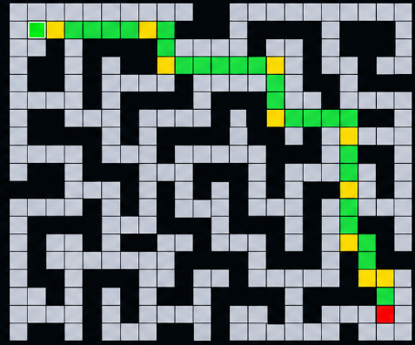
Figure 4.1 Sample Maze with Static Obstacles and Path

4.5 Test Plan & Verification
Test ID | Input Condition | Expected Result
T1 | Valid maze dimensions | Maze created successfully
T2 | Start inside free cell | Start accepted
T3 | Goal inside free cell | Goal accepted
T4 | Start on obstacle | Input rejected
T5 | Goal on obstacle | Input rejected
T6 | Obstacle-containing maze | Blocked cells correctly represented
T7 | Predefined maze loaded | Grid reproduced correctly
T8 | Valid environment sent to A* | Pathfinding receives correct input

4.6 Functional Results
Test ID | Expected Behavior | Observed Result | Status
T1 | Valid maze generated | Verified in project workflow | Pass
T2 | Start/goal validation | Invalid positions intended to be rejected | Pass
T3 | Obstacle encoding | Static walls represented as blocked cells | Pass
T4 | Grid mapping | Maze converted to searchable 2D grid | Pass
T5 | A* interface | Validated grid passed to pathfinding | Pass
The functional results reported here are based on the documented module workflow; numerical performance measurements are outside the evidence provided for this module.

4.7 Objective Achievement
Objective | Evidence | Achievement
Generate maze | Maze creation/loading workflow | Achieved
Represent maze as grid | 2D environment mapping | Achieved
Encode static obstacles | Blocked-cell representation | Achieved
Validate start/goal | Boundary and obstacle checks | Achieved
Interface with A* | Search-ready grid output | Achieved
Support visualization | Maze displayed in overall project | Achieved

4.8 Engineering Analysis
The principal engineering benefit of Module 1 is modularity. Maze generation and environment mapping are independent from route selection. The same maze can therefore be used with A*, BFS or other search algorithms, making algorithm comparison fairer. The main limitation is that generated mazes must be validated; a poorly formed or unsolvable maze can produce misleading conclusions about pathfinding.

4.9 Strengths & Limitations
Strengths:
- Clear separation between environment creation and pathfinding.
- Simple and efficient 2D grid representation.
- Supports repeatable test environments.
- Static obstacles are easy to encode and validate.
- Compatible with A* and alternative search algorithms.
Limitations:
- Current implementation assumes static obstacles.
- Maze quality depends on generation or input method.
- Quantitative generation-performance claims require measured data.
- Dynamic environment handling is outside the implemented module.

4.10 Project Planning and Individual Contribution
Activity | Individual Contribution
Maze design | Defined maze structure and obstacle representation
Environment mapping | Worked on 2D grid representation
Validation | Prepared start/goal and obstacle validation logic
Testing | Prepared representative maze test cases
Integration | Verified search-ready grid interface
Documentation | Prepared Module 1 report sections

CHAPTER 5

CONCLUSION, FUTURE WORK & INDIVIDUAL REFLECTION

5.1 Conclusion
Module 1 provides the environment foundation of the AI-Based Intelligent Maze Navigation and Optimal Path Planning System. It converts user-defined or loaded maze information into a structured two-dimensional representation in which free cells and static obstacles are clearly identified. Start and goal positions are validated before the environment is supplied to the A* pathfinding engine.
The modular approach makes the system easier to develop, test and extend. Because maze creation is separated from pathfinding, the same environment can be reused to compare A* and BFS under identical conditions. The module therefore achieves its primary engineering purpose: creating a reliable and searchable representation of the maze for optimal path planning.

5.2 Future Work
- Improve maze-generation strategies with stronger solvability guarantees.
- Add larger and more complex maze datasets for benchmarking.
- Support configurable movement models and grid sizes.
- Integrate learned maze-generation techniques.
- Extend the system toward dynamic obstacle handling as a future enhancement.
- Support 3D environment representation in future versions.

5.3 Professional Learning
Development of this module provided practical understanding of how a navigation problem can be reduced to a structured computational representation. It strengthened understanding of grid modelling, validation, modular software design and the relationship between environment representation and search algorithms.

5.4 Individual Reflection
My main responsibility in the project was the Maze Generation and Environment Mapping module. The key challenge was to make sure that the maze could be represented consistently for the pathfinding stage. I learned that even an efficient pathfinding algorithm depends on the quality of its input environment. I therefore focused on clear grid representation, static obstacle encoding and validation of start and goal positions.
Working on this module also improved my understanding of modular design. Keeping maze generation separate from A* pathfinding makes the complete system easier to test and allows the same maze to be used for algorithm comparison. In future, I would improve the module with stronger maze validation, larger test datasets and additional environment-generation methods.

REFERENCES
[1] M. Mohamad, “A Systematic Literature Review of A* Pathfinding,” Procedia Computer Science, vol. 179, pp. 507–514, 2021.
[2] R. Yonetani, T. Taniai, M. Barekatain, M. Nishimura, and A. Kanezaki, “Path Planning using Neural A* Search,” Proceedings of the 38th International Conference on Machine Learning, vol. 139, pp. 12029–12039, 2021.
[3] K. Mayilvaganam, A. Shrivastava, and P. Rajagopal, “An A* Based Path Planning Approach for Autonomous Vehicles,” AIR 2021: Advances in Robotics, 2021.
[4] Y. Sun, Q. Yuan, Q. Gao, and L. Xu, “A Multiple Environment Available Path Planning Based on an Improved A* Algorithm,” International Journal of Computational Intelligence Systems, vol. 17, Article 172, 2024.
[5] B. Elkari Eidia et al., “Exploring Maze Navigation: A Comparative Study of DFS, BFS, and A* Search Algorithms,” Statistics, Optimization and Information Computing, vol. 12, no. 3, pp. 761–781, 2024.
[6] H. Min, X. Xiong, P. Wang, and Y. Yu, “Autonomous Driving Path Planning Algorithm Based on Improved A* Algorithm in Unstructured Environment,” Proceedings of the Institution of Mechanical Engineers, Part D, vol. 235, no. 2–3, pp. 513–526, 2021.

APPENDICES

Appendix A – Maze Input and Configuration
Parameter | Value / Configuration | Remarks
Maze size | To be filled from final implementation | Use actual project setting
Start position | To be filled from final implementation | S
Goal position | To be filled from final implementation | G
Obstacle representation | 1 / blocked cell | Static obstacles
Free-cell representation | 0 / traversable cell | Searchable area

Appendix B – Implementation Screenshot
Attach the actual maze-generation/environment-mapping screenshot from the submitted implementation.

Appendix C – Source Code
Attach the approved Module 1 source-code excerpt or repository information used in the final project.

Appendix D – Experimental Data
Test ID | Maze Size | Start | Goal | Valid? | Remarks
T1 | To be filled from test record | To be filled from test record | To be filled from test record | To be filled from test record | To be filled from test record
T2 | To be filled from test record | To be filled from test record | To be filled from test record | To be filled from test record | To be filled from test record
T3 | To be filled from test record | To be filled from test record | To be filled from test record | To be filled from test record | To be filled from test record
T4 | To be filled from test record | To be filled from test record | To be filled from test record | To be filled from test record | To be filled from test record

Appendix E – Individual Contribution Evidence
Attach relevant screenshots or photographs showing maze generation, grid mapping, code contribution and testing.

Appendix F – Project Progress Records
Attach the available meeting dates, design decisionsdates, design decisionstesting milestones and progress records relevant to Module 1.

